Purpose:
This document outlines the method used to account for well venting for liquids unloadings to incorporate in the 2017 Uinta Basin Emission Inventory (UBEI2017) and the changes estimated from findings in the Uinta Basin Composition Study reflected in UBEI2017-Update.

Background:
The Uinta Basin Oil & Gas Emission Inventory (UBEI) is made up of two main components: (1) Operator Workbooks where operators provide prescribed data elements and emission estimates, and (2) Gap-Filling for emissions sources not covered in the Operator Workbooks. Operators annually report to EPA’s Greenhouse Gas Reporting Program, subpart W (Petroleum and Natural Gas Systems), methane emissions and activity counts for well liquids unloading.
In new gas wells, there is generally sufficient reservoir pressure to facilitate the flow of water and hydrocarbon liquids to the surface along with produced gas. In mature gas wells, the accumulation of liquids in the well can occur when the bottom well pressure approaches reservoir shut-in pressure. This accumulation of liquids can impede and sometimes halt gas production. When the accumulation of liquid results in the slowing or cessation of gas production (i.e., liquids loading), removal of fluids (i.e., liquids unloading) is required in order to maintain production. Emissions to the atmosphere during liquids unloading events are a potentially significant source of VOC and methane emissions.
Most gas wells will have liquid loading occur at some point during the productive life of the well. When this occurs, common courses of action to improve gas flow include:
- Shutting in the well to allow bottom hole pressure to increase, then venting the well to the atmosphere (well blowdown, or “blowing down the well”),
- Swabbing the well to remove accumulated fluids,
- Installing a plunger lift,
- Installing velocity tubing, and
- Installing an artificial lift system.

Method:
- From the EPA Greenhouse Gas Reporting Program, subpart W reporting from operators in the Uinta Basin, obtain the activity levels and resultant methane emissions (reported in metric tons). For Reporting Year 2017, operators in the Uinta Basin reported the following for well liquids unloading:
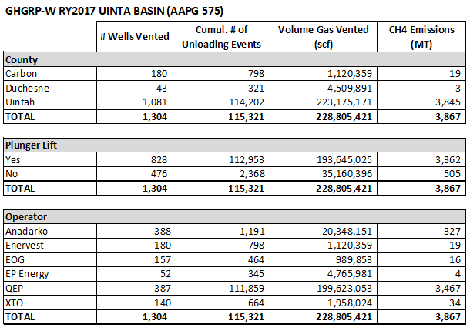
- Obtain speciation data for ‘flash gas analysis for condensate (at gas wells)’ to use as a surrogate ratio of methane-to-VOC weight percent (Wt.%) for the unloading of pressurized liquids from gas wells through an atmospheric storage tank.
  - For UBEI2017:
From the 2014 UBEI, calculate the weighted average (based on # of facilities) of speciated gas streams provided by operators. From the weighted average of ‘flash gas analysis for condensate’, the weight percent of methane (CH4) is 0.3180 and of VOCs is 0.4958.
$$\frac{VOC Wt.\% (0.4958)}{CH4 Wt.\% \left(0.3180\right)× \frac{\left(0.907185\right) MT}{ton}} =1.7184 \frac{VOC ton}{CH4 MT}$$
  - For the UBEI2107-Update based on UBCS findings:
From the UBCS, use the average speciated “Flash Gas: Gas Wells” gas stream derived from 17 gas wells where pressurized liquid samples from the separator were collected and analyzed and those results input to ProMax to model speciated tank flash emissions. The UBCS speciation profiles are shown below:
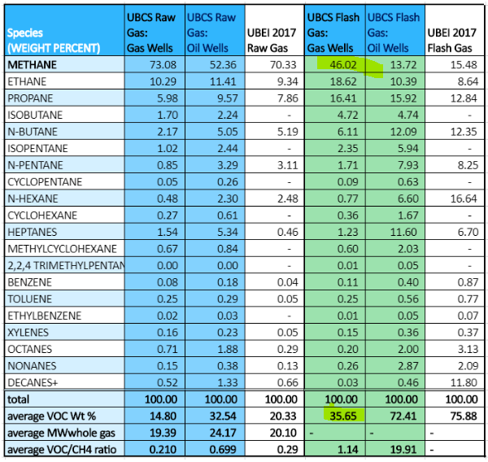
The weight fraction of methane (CH4) is 0.4602 and of VOCs is 0.3565.
$$\frac{VOC Wt.\% (0.3565)}{CH4 Wt.\% \left(0.4602\right)× \frac{\left(0.907185\right) MT}{ton}} =0.8539 \frac{VOC ton}{CH4 MT}$$
- Calculate VOC emissions from well liquids unloading in 2017.
  - For UBEI2017:
$$3,867 MT CH4 ×1.7186 \frac{VOC ton}{CH4 MT } =6,645 ton VOC$$
  - For UBEI2107-Update based on UBCS findings:
$$3,867 MT CH4 ×0.8539 \frac{VOC ton}{CH4 MT } =3,302 ton VOC$$

Results:
We propose to adjust the UBEI2017 ‘Gap-Filling’ line item, well venting for liquids unloadings, by replacing 6,645 TPY VOC with 3,302 TPY VOC (-3,343 TPY).

Uinta Basin Composition Study Comprehensive Final Report, Utah Division of Air Quality. March 31, 2020 https://documents.deq.utah.gov/air-quality/planning/technical-analysis/DAQ-2020-004826.pdf
“Oil and Natural Gas Sector Liquids Unloading Processes”, April 2014 https://www.regulations.gov/document?D=EPA-HQ-OAR-2010-0505-5032

